Historical Drawdown in Python
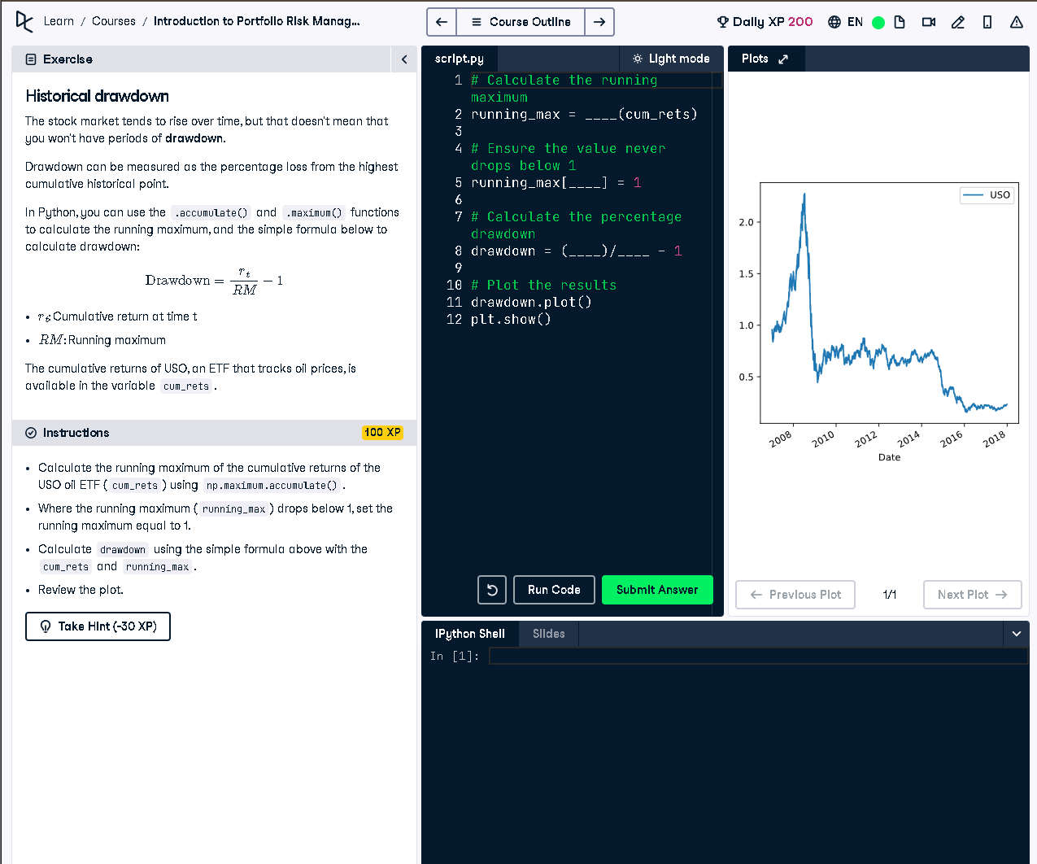
Figure: USO ETF drawdown chart shown in the interface

✅ Full Python Answer
# Calculate the running maximum
running_max = np.maximum.accumulate(cum_rets)
# Ensure the value never drops below 1
running_max[running_max < 1] = 1
# Calculate the percentage drawdown
drawdown = (cum_rets / running_max) - 1
# Plot the results
drawdown.plot()
plt.show()

🧾 Simple Explanation (50 words)
Drawdown measures the decline from a historical peak. We use numpy to calculate the running maximum of cumulative returns. Then we calculate the drop from that peak using the formula: drawdown = (current / max) - 1. This shows the percentage loss from the peak.

